Australian Federation of Disability Organisations
Tranistional arrangements for the NDIS
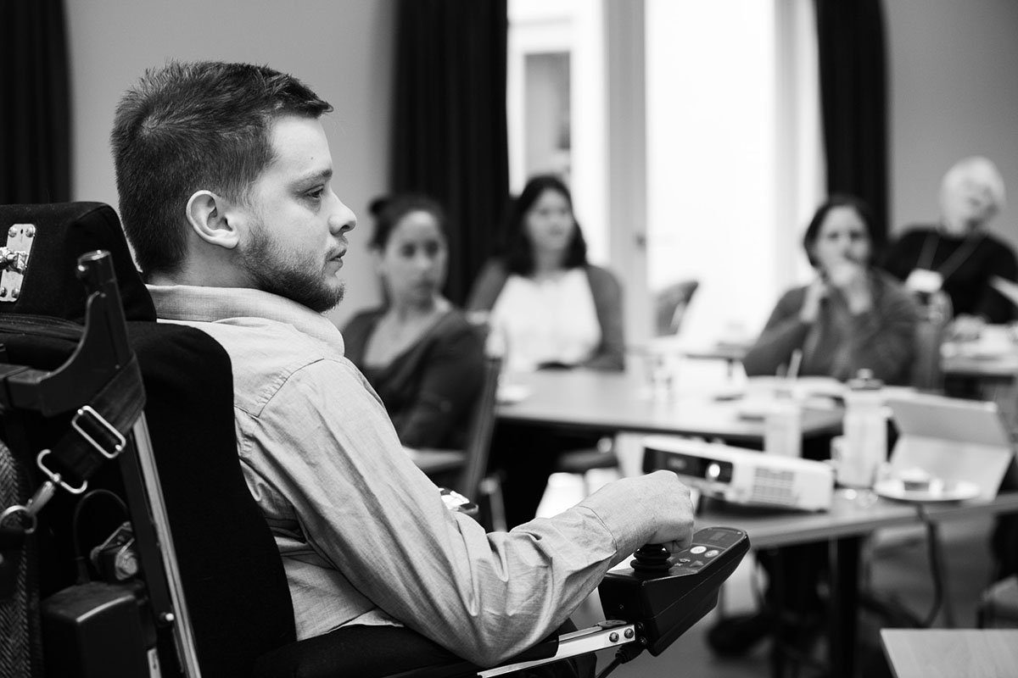
August 2017

Table of Contents
Who is AFDO? 3
Introduction 4
The boundaries and interface of NDIS service provision, and other non-NDIS service provision, with particular reference to health, education and transport services 5
Recommendation 22 7
Recommendation 23 7
Recommendation 24 7
The consistency of NDIS plans and delivery of NDIS and other services for people with disabilities across Australia 8
The rollout of the Information, Linkages and Capacity Building program 10

Who is AFDO?
The Australian Federation of Disability Organisations (AFDO) is the peak organisation in the disability sector representing people with lived experience of disability. AFDO and its member organisations are run by and for people with lived experience of disability.
AFDO’s mission is to champion the rights of people with disability in Australia and support them to participate fully in Australian life. AFDO has strong relationships not just with its member organisations, but across the disability sector including peaks representing service providers as well as those representing families and carers.
As a founding member of the National Disability and Carer Alliance, AFDO played a key role in the campaign for the introduction of the National Disability Insurance Scheme (NDIS). As the NDIS has moved through the trial phase and begun the transition to full scheme, AFDO and its members have continued to work constructively with the National Disability Insurance Agency (NDIA), as well as Commonwealth and State and Territory governments to provide critical feedback and address implementation issues as they arise.
AFDO’s members include:

Blind Citizens Australia
Brain Injury Australia
Deaf Australia
Deafblind Australia
Autism Aspergers Advocacy Australia
Down Syndrome Australia
Physical Disability Australia
Disability Advocacy Network Australia
Disability Justice Advocacy
Disability Resources Centre
People with Disability ACT
Enhanced Lifestyles
People with Disability WA
Deafness Forum of Australia

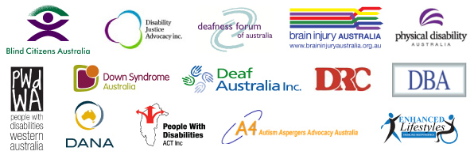

Introduction
As a founding member of the National Disability and Carer Alliance, AFDO played a key role in the campaign for the introduction of the National Disability Insurance Scheme (NDIS). As the NDIS has moved through the trial phase and begun the transition to full scheme, AFDO and its members have continued to work constructively with the National Disability Insurance Agency (NDIA) as well as Commonwealth and State and Territory governments to provide critical feedback and address implementation issues as they arise. (Perhaps rewrite this par - repeated verbatim on p4 Introduction)
AFDO welcomes the opportunity to have input into the NDIS Joint Standing Committee’s inquiry into Transitional Arrangements for the NDIS. We want to begin, however, by emphasising our unwavering support for the NDIS. AFDO and its members regularly hear from people with disability and their families about the difference the NDIS is making to their lives. People who now have the dignity of appropriate and timely support, the opportunity to be more involved in their communities, the chance to move out of home, the economic freedom of a new job. These are the kinds of differences the NDIS is making.
AFDO and its members were all too familiar with the failings of the previous disability system, which the Productivity Commission infamously characterised as “inequitable, underfunded, fragmented, inefficient and gives people with disability little choice and no certainty of access to appropriate supports”. AFDO and its members were highly critical of the previous system and its chronic failure to neither provide appropriate support to people with disability nor close the gap in life outcomes between those with a disability and those without.
AFDO remains committed to the vision of the NDIS and is determined to ensure it is implemented in full. AFDO strongly opposes any attempts to deviate from the original vision and intent or to curtail its implementation. The comments that follow should therefore not be interpreted as lack of support for the scheme. They represent AFDO’s thoughts about how to ensure the scheme is the best it can be, identifying issues and areas that warrant further attention, analysis and action. We want to see the scheme reach its full potential and improve outcomes for people with disability.
Finally, our comments should also be considered in the light of the importance of ensuring people with disability are at the heart of the scheme. Any decisions made in the interests of ensuring sustainability should also be consistent with improving outcomes for people with disability. We should not put other interests – the interests of the system, the interests of governments, and the interests of service providers - ahead of the interests of people with disability. The sustainability of the scheme is of vital importance to people with disability – people with disability understand it is essential to the longevity of the scheme. The scheme must always put people with disability first.

The boundaries and interface of NDIS service provision, and other non-NDIS service provision, with particular reference to health, education and transport services
Recommendation
For the Disability Reform Council to initiate a process of review around the Interface Principles incorporating lessons learned from the transition period.
In the experience of AFDO and its members, lack of access to mainstream services, poor service response and failure of communities to address issues of inclusion contribute to poor life outcomes for people with disability. These three issues routinely feature in the complaints by members to their peak organisations and dominate the workloads of advocacy organisations.
These failures also place significant pressure on NDIS participants to include supports and services in their individual plans to meet needs which rightly should be met by mainstream services. It also means that people with disability who sit outside the scheme and who are not eligible for individualised support do not have their needs addressed. This in turns places pressure on these individuals to test their eligibility in order to try and receive appropriate support.
Sometimes the pressure to include supports in NDIS plans that are more appropriately provided by the mainstream services comes from people with disability themselves. Desperate for support and for a resolution to the never-ending message “we are not funded to do that”, people just look for any means necessary to have their needs met.
In other cases the expectation of support from the NDIS has come from mainstream services themselves. In our view, there is an unrealistic expectation amongst many mainstream services that the NDIS would assume responsibility for meeting any need a person with disability might have. The idea that they have a universal service obligation to the community seems to have come as a surprise.
In other cases government itself has been responsible for creating boundary issues. This appears to be particularly true in the area of mental health. Funding for some community mental health services in particular has been diverted to the NDIS, with an expectation that people with psychosocial disability would receive support from the scheme. This is despite the fact that only some people with psychosocial disability who currently rely on community mental health services will in fact be eligible for an individual NDIS plan. The rest will need to draw on activities funded through Information Linkages and Capacity Building (ILC) or remain unsupported. Demand on ILC already exceeds the budget allocated to it, and it is expected to provide assistance to people with a diversity of disabilities, not only those with mental health conditions. This is an issue which is beyond the remit of the scheme – it must be resolved by government.
During the trial phase, continuity of support arrangements appear to have “masked” some of the failure of mainstream services to meet the needs of people with disability. In combination with the smaller number of people supported by the scheme, AFDO believes the full impact of mainstream failures and a lack of community inclusivity is yet to be felt. Some of the boundary issues are still yet to fully emerge and it is probable that the impact on scheme costs is yet to be fully realised.
These “boundary” issues have been highlighted in an NDIS test case that was resolved just as AFDO was preparing this submission. A young man with an intellectual disability and living in a small town outside of a regional centre has been a participant in the NDIS during trial. His participation in supported employment and social activities in the regional centre was funded as reasonable and necessary supports in his plan. Initially all of his transport costs to and from these activities were also funded. But the NDIA attempted to reduce the amount of funding allocated to transport, and he and his family appealed the decision. The Federal Court this week upheld the decision. The NDIS will now be responsible for meeting all of his transport costs.
The first thing that must be said is that we are pleased this young man will be adequately supported to achieve his goals. We believe the policies underlying planning decisions must be transparent. But it should also be noted that the young man requires additional transport into the nearest regional centre because there is no public transport in his town. This is a failure of the public transport system – not the disability system. It should also be noted that this young man travels into the nearest regional centre for both supported employment and social activities. If employment was available closer to his home, and he was able to participate in social activities in his local town, then the need for transport into the regional centre would be reduced. This would be a better outcome for this young man and his family, a better result for his town, and a better outcome for the scheme. This case provides a clear example of the ways in which failings in the mainstream (system/services?) are both directly and indirectly resulting in significant cost shifting to the scheme.
Another good example of significant confusion concerning boundary issues involving the NDIS and a mainstream service system lay in the issue of people with disabilities involved in the criminal justice system. The recent NDIS Joint Standing Committee inquiry report into psychosocial impairment made the following recommendations around the interaction of the NDIS and people with disabilities in the criminal justice system.

Recommendations from the psycho-social impairment inquiry report include:

Recommendation 22
The committee recommends the NDIA urgently clarifies what approved supports are available to NDIS participants in custody and how it monitors and ensures NDIS participants access the supports they are entitled to while in custody.

Recommendation 23
The committee recommends the NDIA establishes an NDIA unit specialising in the interaction of the Scheme with the criminal justice system.

Recommendation 24
The committee recommends the NDIA develops a specific strategy to deliver culturally appropriate services for Aboriginal and Torres Strait Islander people with disabilities who are in the criminal justice system.

The consistency of NDIS plans and delivery of NDIS and other services for people with disability across Australia
Recommendation
For NDIS Planners to have access to regular and current information, informed by people with disabilities and the services that provide support to them, about the impact of disability on their lived experience
AFDO remains concerned about the access and implementation issues associated with the planning process and the quality of the plans as a result. Whilst the AFDO membership does not wish to see a slow-down in the roll out for transition to full scheme it is clear that the pace of the rollout is having an impact on the quality of both the planning process and the quality of the plans themselves.
People with cognitive impairments and complex care issues, including psychosocial impairment, their families and carers are particularly vulnerable in the context of the impact on the planning process. Other groups of people that are vulnerable in the context of the impact of the roll out schedule on the quality of the plans produced are Indigenous Australians, people whose first language may not be English, and people with disability who live on the fringes of society.
For example, people with cognitive impairments form the largest group of scheme participants but on the whole do not fare well in a telephone planning conversation. Given the abuse, neglect and exploitation that people with disability have experienced historically, there is no way of being certain that people are not being coached, harassed or bullied when planning is undertaken over the phone. Generally speaking, for people with a cognitive impairment and complex care issues it is important that they are supported to participate in the planning process and that the planning occurs face to face. These complexities add to the problem faced by the NDIA in adhering to roll out schedules whilst ensuring quality planning can occur. It seems reasonable on the face of it, given these pressures,that the Agency may be looking at strategies where they could continue the roll out schedule and diversify responsibility for Plan approval.
The quality of the plans produced would be enhanced by:
- Increased levels of awareness and understanding by planners about the social model of disability and its relationship to living with an impairment
- Regular updates on the lived experience of disability
- Informed and current training on the diversity and range of disability
- Access to specialist disability information
- The opportunity or participants to review their plans before they are finalised
- Planning processes that were accessible and plans that were provided in accessible formats
- Planning processes that are co-designed with people with disability
- Planning processes and plans that are available in languages other than English
- Planning processes and plans that are available in plain language, Easy English and Australian Sign Language

- Access by planners to cultural knowledge and brokerage for Indigenous Australians
AFDO supports the recommendation by the Queensland Public Advocate in their Submission to this inquiry that the
“NDIS planning processes should undergo immediate independent review with the aim of improving both the planning process and the quality of the NDIS plans, reducing requests for early reviews and ensuring that plans address the fundamental needs and interests of participants”

The rollout of the Information, Linkages and Capacity Building program

Recommendation
Funding for Information, Linkages and Capacity Building (ILC) should be increased to the full scheme amount (of $131 million) for each year during the transition.
The Productivity Commission, in its original report into Disability Care and Support recognised that the provision of greater individualised funding alone could not achieve improved life outcomes for people with disability. The report argued that there would remain activities or supports that could not effectively and efficiently be individualised but were still essential to effective support. The report also recognised that there would be a group of people with disability who still required some forms of support but whose functional impairments would not meet the threshold established for the scheme. Tier 2 would therefore be both a population group and a collection of activities.
In July 2015 the Disability Reform Council renamed Tier 2 Information, Linkages and Capacity Building and released the agreed ILC Policy Framework. The policy described the kinds of activities that would be funded through ILC in the future, grouped into five areas – information, linkages and referrals, capacity building for mainstream services, community awareness and capacity building, individual capacity building and local area coordination (LAC). The NDIA has since made it clear that LAC will be implemented separately. The budget for the remaining four areas described in the policy is $132 million per annum.
It would be an understatement to say that the policy intent of COAG has not been matched with the budget allocation for ILC. There are insufficient funds to meet the policy intent outlined in each of the four areas. The budget for ILC must not only be spread across all four activity areas, but also provide appropriate geographic coverage – particularly meeting the needs of people with disability and their families living in rural and remote areas, where the cost of delivering activities is likely to be higher.
The budget must also meet the diverse needs within the disability community and in particular, provide diagnostic specific support as well as meeting generalised information, support and referral needs. It is something of a “Herculean task” to expect $132 million to effectively meet the diversity of need across the geography of the country. But it is not the only task ILC is expected to perform.
In addition, ILC has particular responsibility for people with disability who sit outside the scheme. For the scheme to operate efficiently and effectively, there should be minimal difference between those who are just eligible for the scheme and receive a small individualised package, and those who sit just outside the scheme and have their needs met by ILC. To do otherwise is to create an incentive to test eligibility to move into the scheme. This is a very important function of ILC and implemented well would make a significant contribution to scheme sustainability. Despite the importance of this function and the significance of this group, little is known about their characteristics, their likely support needs and the quantity of funding required to ensure they are appropriately supported. This is an area of research and analysis that warrants further attention.
The effective implementation of ILC is of vital importance to AFDO and its members, as there is great potential for ILC to drive inclusion across the community. For ILC to deliver on its promise, progress will have to be made in two areas –
- Ensuring people with disability and their families have the knowledge, skills and resources they need to live the life of their choosing
- Making sure mainstream services and community supports, programs and activities have the knowledge and skills they need to be accessible and inclusive.
Improved life outcomes for people with disability will not be achieved unless progress is made concurrently in both areas. Both will also make an important contribution to scheme sustainability – as people are engaged with and included in their communities and well supported by mainstream services, reliance on paid specialist disability supports will reduce over time.
The current budget allocated to ILC is unlikely to ensure significant progress in these areas – one may be possible, but not both. Given progress in one is linked to progress in the other, in our view the outlook for ILC is grim. As it stands, one of the very foundation stones of the scheme has been weakened by a broad policy, a limited budget and a lack of clarity about individuals who most need assistance and what support they might require.
There are four potential solutions to this issue:
- Reduce significantly the scope of the ILC Policy so it better matches the current budget.
- Increase the ILC budget significantly.
- A combination of both 1 & 2.
- Allow the NDIA greater flexibility in administering its funding envelope to meet both package costs and the demands of operating an effective ILC.
Given that an increased budget is highly unlikely in the current fiscal environment, it would seem a sensible approach to allow the NDIA greater flexibility in the way in which it apportions the budget it is currently allocated.

